بروجيكت مادة الكمبيوتر

اسم الطالب : احمد خالد فتحي احمد

الكلية : هندسة شبرا

جروب : 1

سكشن: 3

رقم الجلوس : 59

الفرقة :الاعدادية

الموضوع : Artificial Intelligence

**What is Artificial Intelligence (AI)?**

**Artificial intelligence has become the new buzzword leaving IoT, Big Data, Automation, Augmented Reality, and Virtual Reality in shade. Many people believe this is all just hype. The reality is, the different subfields of AI are already being used in medicine, the automotive industry, quantum physics, the financial world, manufacturing and different types of business software.**

**The general definition of Artificial Intelligence is – a computer program that can carry out a complete simulation of the human brain. While this is not wrong and creating a self-teaching AI that will mirror human learning might be the ultimate goal for some researchers, it’s not the whole truth. The scope of Artificial Intelligence is much broader, including technologies like Virtual Agents, Natural Language Processing, Machine Learning Platforms, and many others.**

**Screen shots**

**Home page**

**Web:**

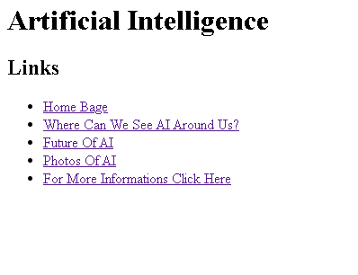

**code:**

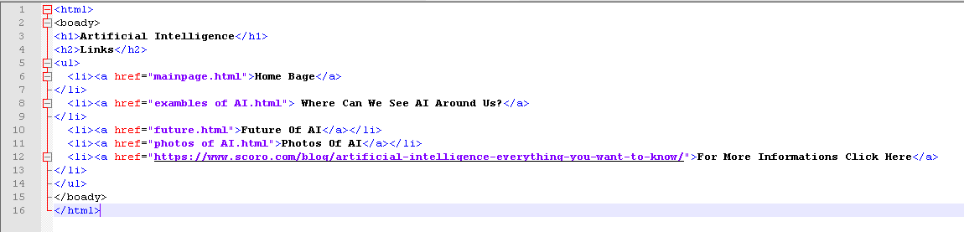

**Where we can see AI Around Us?**

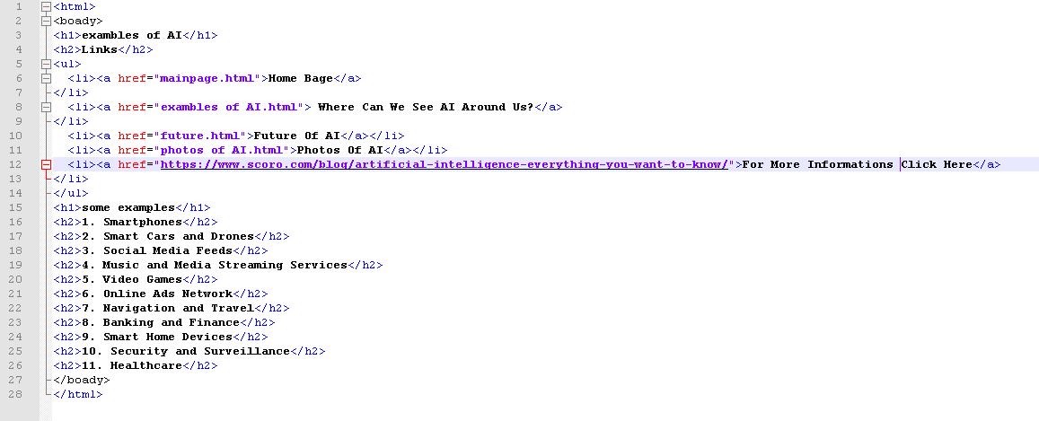

**Web:**

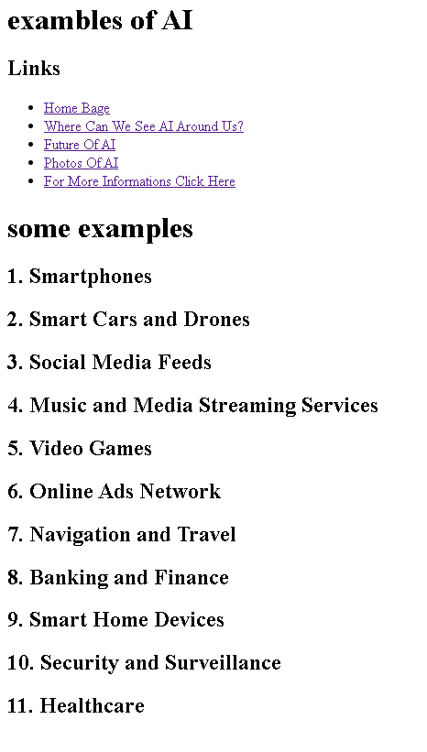

Future Of AI

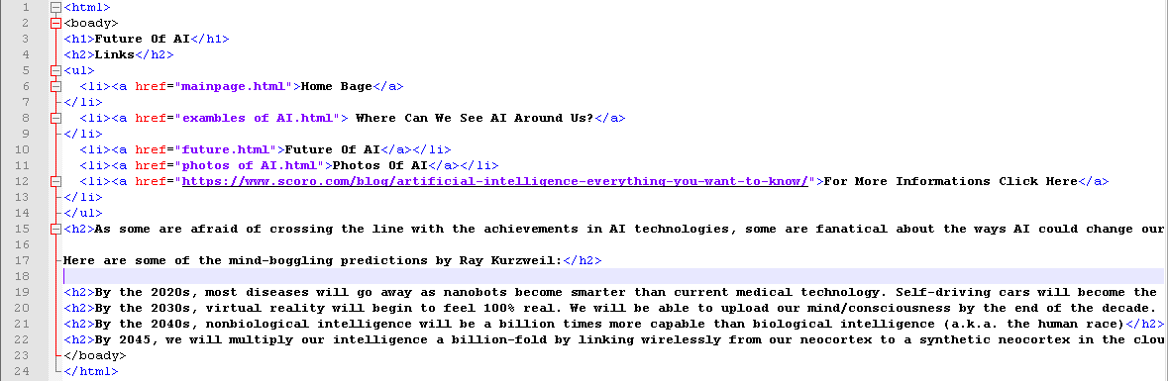

Web:

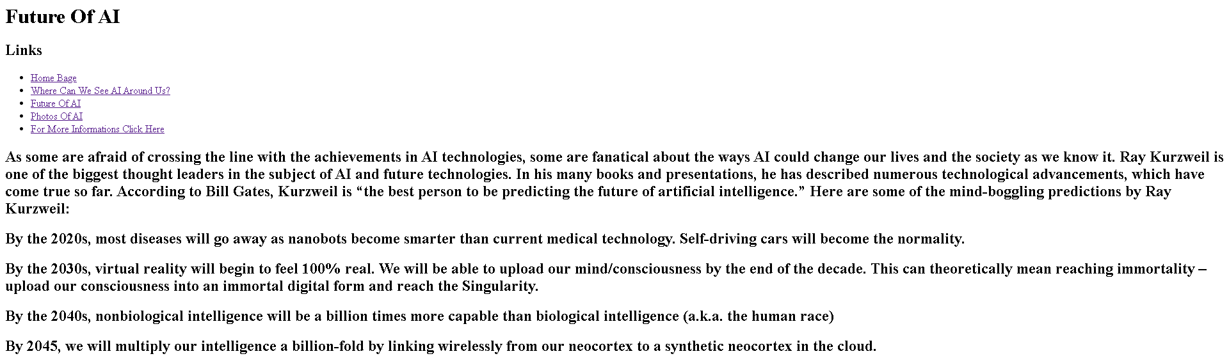

Photos Of AI

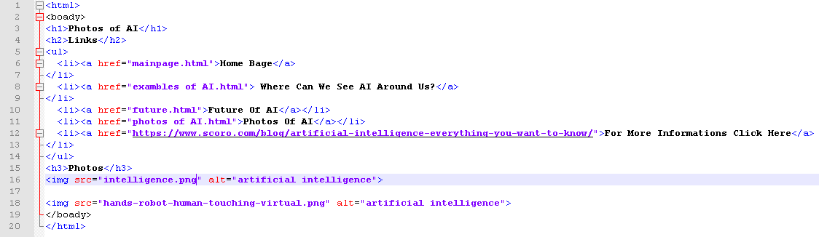

Web:

